B1 – 10mm Model Comparisons

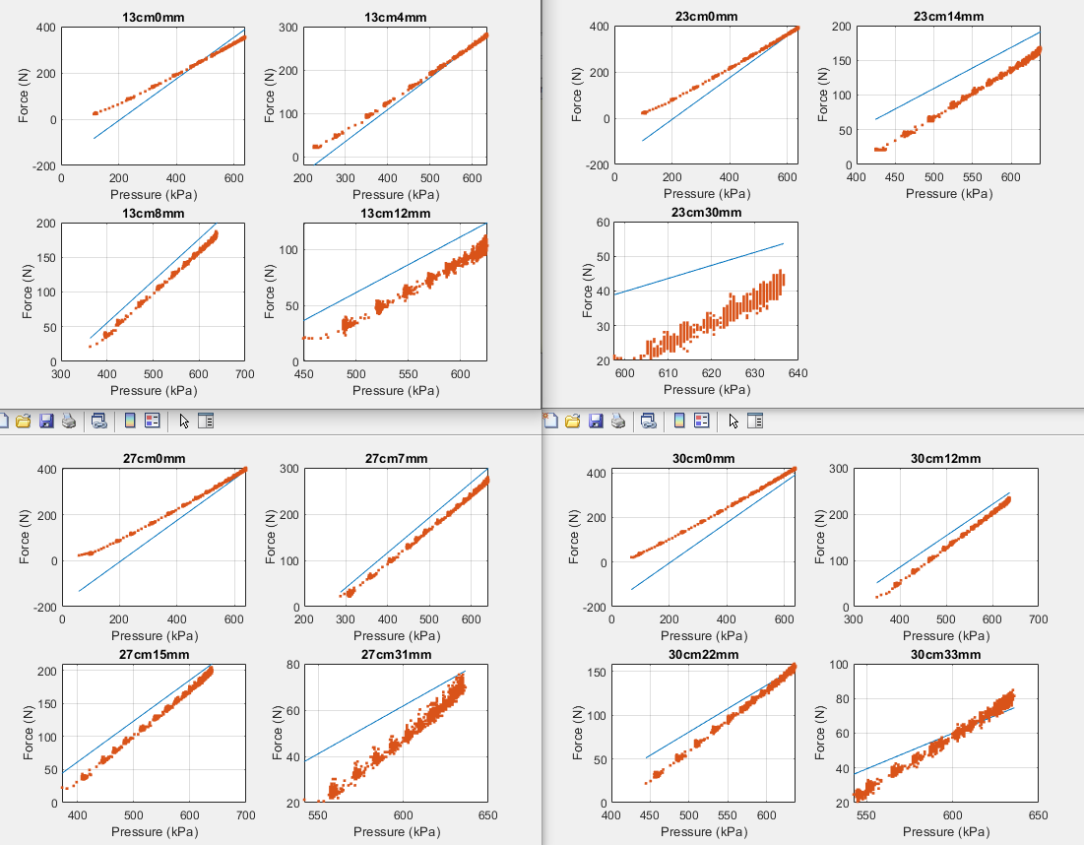Model: Force = c0 + c1(exp(1-erel))\*Pressure +c2(Li)Pressure Force = c0 + c1 (1-Erel)\*Pressure+c2(Li)Pressure

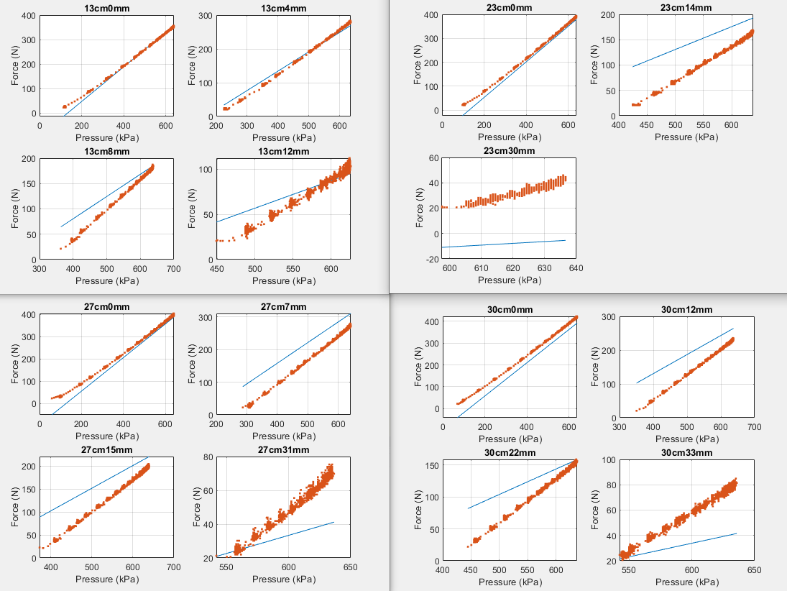

Force = c0 + c1(exp(-Erel))Pressure +c2(li)pressure Force = c0 + c1(exp(-Erel^2))Pressure+c2(li)pressure

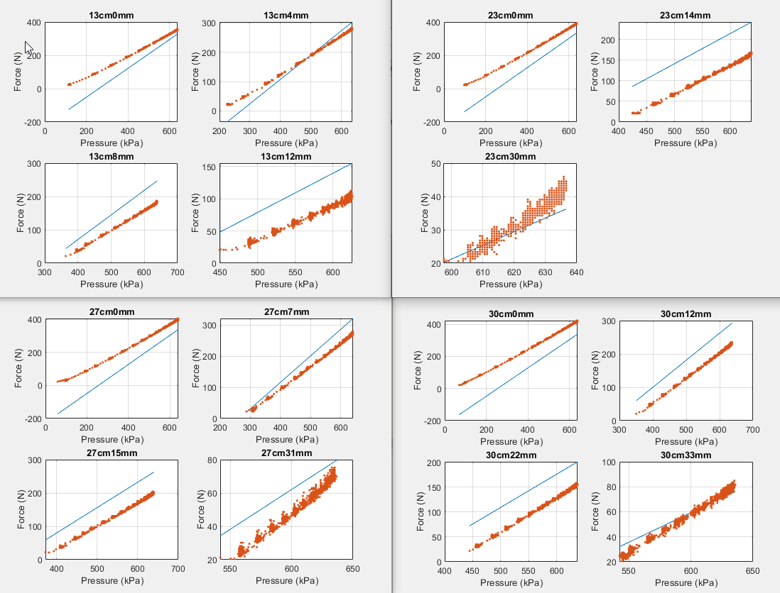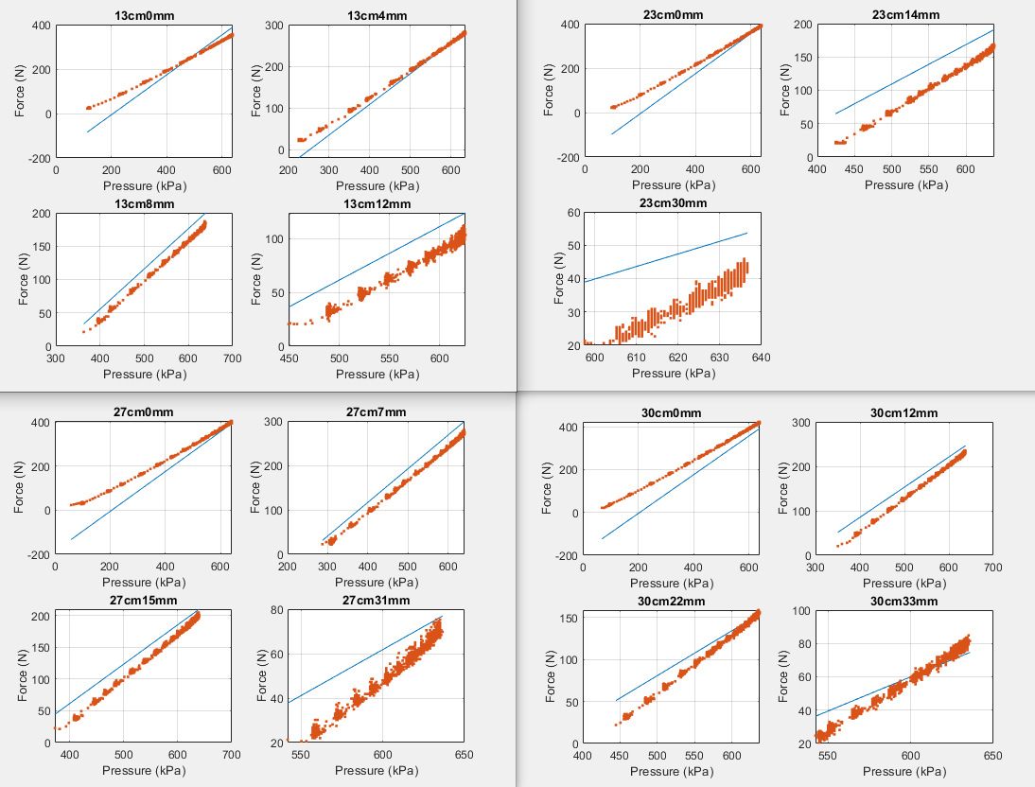

Force = c0 + c1(1-Erel)^2Pressure + c2(li)Pressure

